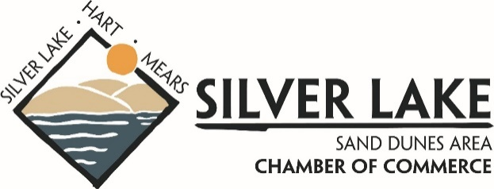
your business… is our business

It’s that time of year again… our chance to thank you for being an anchor business in our community and to express our gratitude for your ongoing support of the Hart and Silver Lake Area Chamber of Commerce!
BOARD OF DIRECTORS:

Wes VanderWilk
President
Silver Lake
Whippy Dip

Jeff Swanson
Vice President Country Dairy

Nichole Kleiner Secretary
City of Hart Economic Development

Janet Dodge
Treasurer
Coldwell Banker- Woodland Schmidt Real Estate

Grant Boring
Website Chair
Peterson Farms

Jenny Ferels Marketing Chair
Lewis Adventure Farm & Zoo

OPEN POSITION
Call 231-873-2247 if you are interested in being a part of our leadership team!
This is also our chance to celebrate what your Chamber of Commerce is able to do for Hart, Mears and Silver Lake because of your support:
Chamber Events: Hart Easter Egg Hunt, High School Summer Job Fair, Business After Hours networking, Blessing of the Duners, Silver Lake “Thunder Over the Dunes” Fireworks, Apple & BBQ Festival, support for Hart Sparks fireworks, Hart’s Home for the Holidays Christmas Parade, Hart holiday garland and wreath decorations.
Promotions: Silver Lake/Hart directional billboard at US-31 exit and Downtown Hart billboard at West Polk Rd. Distribution of 40,000 Visitor Guides, 30,000 Area maps and 5,000 Community Guides in Oceana County and Welcome Centers throughout the state. Your business listed on one of Michigan’s top visitor-destination websites “thinkdunes.com” with over 1.5 million clicks per year… that’s $0.0003 per click for members!
Sponsorships: Members have the opportunity to be front and center at community events through exclusive sponsorship opportunities.
Partnerships: With area civic and non-profit organizations such as Oceana College Access Network, Community Foundation, Oceana County Economic Alliance, Hart Historic District, Hart Rotary, Hart Economic & Redevelopment Team, Oceana County Fair, and United Way of Oceana County.
On behalf of the Board of Directors and our entire membership, “Thank You” for your membership. A renewal invoice is enclosed. Please contact me or a current board member if you have any questions or if you are interested in a position on the board of directors (we have an open seat). We look forward to another successful year… together!

Sincerely,

Scott Beal
Executive Director
Office: 231-873-2247 | Cell: 231-742-3883

